CLEAR LAKE PRICKLY SCULPIN

Cottus asper ssp. (Richardson)

Status: Class 3. Watch List. The Clear Lake prickly sculpin appears to be in a slow decline and is confined to Clear Lake, Lake County, which is subject to rapid changes in water quality and invasion by alien species.

Identification: Prickly sculpin can be identified by their long dorsal and anal fins (Moyle 2002). Fin spine and ray counts are 7-10 soft spines in the first dorsal fin, 19-23 rays in the second dorsal fin and 16-19 rays for the anal fin. The dorsal fins join at the base. Pelvic fins have one spine fused with the first ray and 3 additional rays. The pectoral fins have 15-18 rays. They have 5-6 gill rakers, 6 branchiostegal rays on each side, and 2-3 pre-opercular spines of which only one is usually observable. The lateral line has 28-43 pores and is complete. Palatine teeth are easily observable. They normally have one, but occasionally two, pore(s) on the chin. The caudal peduncle is rounded and narrow in relation to body depth. Prickling on the body ranges from all over (common in younger individuals and inland populations) to only behind the pectoral fins. Coloration also varies but is usually mottled reddish brown to dark brown with 4-5 dark saddles on the dorsal surface and light yellow to white on the belly. Fins are usually barred and the first dorsal commonly has a dark spot where it meets the second dorsal fin. During breeding, males turn very dark and both sexes develop orange edges on the first dorsal fin. Non-breeding males can be distinguished from females by their long, V-shaped genital papilla. Clear Lake prickly sculpin have a longer anal fin (ca. 18 rays), broader pectoral fin (17-18 rays), smaller typical adult body size (<60 mm TL), and more heavily prickled skin than most other California prickly sculpins.

Taxonomic Relationships: Prickly sculpin are physically very variable, widely distributed and have poorly studied systematics (Kresja 1965, 1970). Although pelagic larvae distribute widely, it is likely that genetic differences exist between subgroups. Three distinct forms of prickly sculpin exist in California: the coastal form, Central Valley form, and Clear Lake form (Hopkirk 1973). Hopkirk (1988) claimed that the Clear Lake form merited subspecies status based on the number of anal (ca. 18) and pectoral (17-18) fin rays, the amount of prickling on the adult and trophic adaptations for feeding on small benthic invertebrates. The coastal form inhabits coastal streams and estuaries and is lightly prickled. The Central Valley form inhabits freshwater and the San Francisco Estuary and is completely prickled. The Clear Lake form inhabits Clear Lake and is partially prickled.

Life History: Clear Lake prickly sculpin are most commonly found near shore, associated with beds of tules and gravel substrates (Week 1982). Assuming they have similar life history to other forms, they spend most of their time lying on the bottom during the day and become more active at night. Prickly sculpin are not thought to be gregarious, although schools of prickly sculpin have been observed near lakeshores in British Columbia (Northcote and Hartman 1959). They are not territorial outside of the breeding season.
Clear Lake prickly sculpin complete their entire life cycle within the lake (Broadway and Moyle 1978). Adults move into spawning areas from March through May, usually into habitats with moving water and rocks under which males locate nests. Presumably in Clear Lake this means areas containing volcanic rocks. Males build nests by excavating a small area beneath rocks and then cleaning the underside of the rock where eggs will attach. Males lure females into the nest where courtship continues mostly at night (Kresja 1965, 1970). Eggs are clustered and attached to the ceiling of the nest. Once spawning is complete males chase females from the nest and guard embryos until they hatch. Males move in the nest to facilitate water circulation over the eggs and ensure hatching (Moyle 2002). Males can mate with more than one female so one nest can have as many as 30,000 eggs but is usually much less (Kresja 1965, 1970). Fecundity ranges from 280 to 11,000 eggs per female depending on size and age (Patten 1971). In lakes, such as Clear Lake, larvae swim up into the water column upon hatching (5-7 mm TL), live as plankton for 3-5 weeks and eventually settle as juveniles (15-20 mm) on the bottom. Juveniles in lakes move into shallow water upon settling (McLarney 1968). Juveniles move offshore as they grow, but move inshore to feed at night (T. Ford, UC Davis, unpubl. rpt. 1977; Broadway and Moyle 1978). Juveniles may benefit from separating themselves from adults because cannibalism is common and competition with larger individuals may decrease growth rates (Pfister 2003).
Prickly sculpin feed primarily on benthic insects such as blackfly, midge, mayfly, stonefly and caddisfly larvae. They will also consume mollusks, isopods, amphipods and small fish. In Clear Lake, 74% of their summer diet was originally chironomid midge larvae and pupae (Cook 1964). While feeding on chironomids continues to be common, amphipods became an abundant prey item in their diet after the introduction of Mississippi silverside, Menidia audens (Broadway and Moyle 1978, L. Decker and M. LeClaire, UC Davis, Unpubl. Rpt. 1978). However, amphipods were more commonly eaten inshore while chironomid larvae were more common in fish captured offshore. Clear Lake prickly sculpin feed throughout the day but more intensely at sunrise and sunset. The rate for complete digestion of one chironomid larva is about 7 hours (T. Ford, UC Davis, Unpubl. Report 1977). Diets of fish collected from sandy substrates are less varied than in those collected from rocky substrates. Their diets vary little with size with the exception of pelagic larvae which fed on planktonic copepods and cladocerans (Broadway and Moyle 1978, Eagles-Smith et al. 2008). However, ontogenetic shifts in diet, from small invertebrates to larger invertebrates and fish, have been noted for prickly sculpin in Lake Washington (Tabor et al. 2007). Prickly sculpin are prey to other species but are not common in diets even where they are abundant. However, predation affects their behavior because they are often associated with cover (Cook 1964, White and Harvey 2001) and are most active at night.
Clear Lake prickly sculpin growth is highly variable. One study found young of the year on average measured 26 mm SL, while 1+, 2+, 3+, and 4+ measured 34 mm, 44 mm, 48 mm, 55 mm, respectively (L. Decker and M. LeClaire, UC Davis, unpubl. Rpt. 1978). Another study determined Clear Lake prickly sculpin to measure 28 mm SL as 1+ and 35-45mm as 2 to 5+ (T. Ford, UC Davis, Unpubl. Rpt. 1977). One individual was aged at 5+ at 95 mm SL. However, lengths for 3+ fish ranged from 30-90 mm. The length-weight relationship for Clear Lake prickly sculpin was determined by Ford (1977) to be W = 1.02 x 10⁻⁵ SL^{3.19}, where SL is standard length.

Habitat Requirements: The Clear Lake prickly sculpin is adapted for life in a warm (summer temperatures 25-28 C), shallow (average depth 6.5 m) lake, with mostly sandy or soft bottom substrates. The lake is eutrophic, alkaline (pH of ca. 8), and fairly turbid (Secchi depth, <2m) (Suchanek et al. 2008). This is one of the more extreme environments for occupied by this remarkably adaptable species which lives in widely different habitats throughout its range; from freshwater to saltwater; from small, cold, clear streams to large, warm, turbid rivers; and from small eutrophic ponds to large mesotrophic lakes. Their presence in this wide a range of habitats suggests that prickly sculpin are very tolerant of some environmental variables. However, their absence distribution in the San Joaquin Valley floor (Brown 2000) suggests that water quality may limit their distribution (Moyle 2002). Laboratory studies suggest that prickly sculpin can withstand temperatures up to 30.2°C but begin to experience increased mortalities at temperatures above 24°C, when acclimated to 18-19°C (reviewed in Martin et al. 2007). Prickly sculpin in the laboratory also experienced increased mortalities when dissolved oxygen concentrations are below 1.9 mg/L, although field studies have documented that prickly sculpin distribution is restricted to dissolved oxygen concentrations above 3.8 mg/L.

Distribution: Clear Lake prickly sculpin are found only in Clear Lake, Lake County, a large natural lake. Clear Lake is the largest freshwater lake in California (not counting Lake Tahoe, which is partly in Nevada). It is located in the coast range at 402 m elevation and has a surface area of about 17,670 ha (Moyle 2002). Its average depth is 6.5 m while the maximum depth is 18 m. The lake has been highly productive for thousands of years as a result of shallow, warm, well-mixed waters. Other forms of prickly sculpin are found in streams, lakes, and estuaries from the Kenai Peninsula, Alaska, south to the Ventura River, California.

Trends in Abundance: Prickly sculpin are apparently abundant in Clear Lake (Broadway and Moyle 1978). However, recent collection data indicate that, while the population experiences wide fluctuations, the general trend is declining (Figure 1). Eagles-Smith et al. (2008) found sculpin to be one of the most common fish in the lake, with no significant changes in density (based on area seined) from 1986 through 2004.

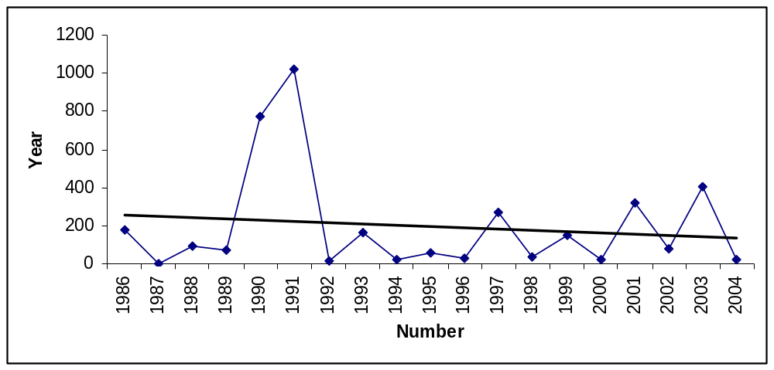
Figure 1. Number of Clear Lake prickly sculpin caught through standardized seining, Clear Lake, 1986-2004. (Data from the Clear Lake Vector Control Agency, courtesy of C. Eagles-Smith).

Nature and degree of threats: Clear Lake is a highly altered natural lake. It is highly polluted with nutrients, sediment, heavy metals, and pesticides from multiple sources and subject to invasions of many species of alien fish, invertebrates, and plants (Table 1). These changes resulted in the disappearance of six native species of fish from the lake, including the endemic Clear Lake splittail (Pogonichthys ciscoides). Amazingly enough, four native species have persisted despite the changes, including Clear Lake prickly sculpin. The ability of the sculpin to persist in the face of rapid change and cumulative effects, especially predation by large populations of alien fishes, is in doubt, however.
Major dams. Cache Creek Dam was built in 1914 to provide water for Yolo County agriculture. The effects on sculpin populations are not known.

 | Rating | Explanation
Major dams | Low | Cache Creek Dam regulates lake levels.
Agriculture | Intermediate | Agricultural runoff contributes to eutrophication and pesticide loads
Grazing | Low | Overgrazing has been a problem since the 1800s and has contributed to sedimentation and nutrient loading in the Lake
Rural development | Low | Development has drastically altered shorelines and increased eutrophication
Urbanization | Intermediate | Urban runoff is a source of nutrients and pesticides
Instream mining | N/A
Mining | Intermediate | Mercury levels in lake fishes are highest in benthic foragers such as prickly sculpin
Transportation | Low | Roads along the lake shore can contribute pollutants and sediment
Logging | Low | Erosion rates from timberlands have likely increased the amount of fine sediment delivery to the Lake
Estuarine alteration | N/A
Recreation | Low | Motorized boats can increase pollution from oil and gas and disrupt fish habitat use
Fire | Low | Wild and human-induced fires are common in Clear Lake watersheds and can increase sediment delivery to the lake
Harvest | N/A
Hatcheries | N/A
Alien species | High | At least three alien species likely compete with prickly sculpin. Introduced piscivores can prey on sculpin
Table 1. Major anthropogenic factors limiting, or potentially limiting viability of Clear Lake prickly sculpin populations in California, where a factor rated “high” is a major limiting factor, a factor rated “intermediate” is a factor that has the potential to be a major limiting factor but has had only a moderate effect so far on population viability, and a factor rated “low” has a low or unknown effect on population viability. Certainty of these judgments is moderate.

Agriculture. The Clear Lake basin is the site of fairly intense agriculture which sends effluent, including fertilizers, sediment and pesticides, into the lake, much more historically than today. The fertilizers and sediment contributed to accelerated eutrophication in the 20th century that resulted in major blooms of blue-green algae, but sculpin persisted through the worst periods. However, die offs of prickly sculpin elsewhere have been attributed to low dissolved oxygen concentrations associated with the senescence of algal blooms (Martin et al. 2007), including that of cyanobacteria found in Clear Lake.
Grazing. Heavy grazing of Clear Lake watersheds has occurred since the 1870s and has likely contributed to sedimentation and nutrient loading of the lake (Suchanek et al. 2002). Effects on sculpin are not known.
Rural development. As Clear Lake became popular as a resort area in the 19th century, the lakeshore became increasingly developed with vacation and permanent homes. This development filled wetlands on the lake margin which trapped sediment and nutrients, added septic tank effluent to the lake, and caused large-scale application pesticides to the lake to control pestiferous gnats. Sculpin persisted despite the changes to lake characteristics.
Urbanization. The many small towns around the lake also contributed to eutrophication through sewage spills, increase in sedimentation, and removal of wetlands. Townspeople were leading proponents of applying pesticides to the lake. In particular, dichloro-diphenyl-dichloroethane (DDD) was applied (1949, 1954, 1957) to control gnat populations. DDD accumulates in the fatty tissues of fish perhaps affecting survival and reproduction (Hunt and Bischoff 1960).
Mining. The Sulphur Bank Mercury Mine dumped mining waste containing mercury directly into the Oaks Arm of the lake and shore from 1922-1947 and 1955-1957 (http://www.atsdr.cdc.gov/HAC/PHA/sulphurbank/sbm_p1.html). These wastes contaminated the lake ecosystem with mercury and arsenic (summarized in Suchanek et al. 2002). Elevated levels of mercury introduced have been found in fish and waterfowl. A current health advisory (first issued in 1986) recommends that not more than one fish from Clear Lake be consumed per week. The water column does not seem to contain high concentrations of methyl mercury, in contrast to some lake sediments. Mercury concentrations in Clear Lake fishes appears to be directly correlated to the extent of benthic foraging, making prickly sculpin particularly susceptible to mercury bioaccumulation (Eagles-Smith et al. 2008). Indirect effects from mercury exposure include behavior disruption (prey capture, inhibition of reproduction), reduced growth rate, and disruption of physiological functions (olfaction, thyroid function, blood chemistry; Suchanek et al. 2008). However, the physical and biological attributes of the lake, including its size, alkalinity and lack of a developed hypolimnion, appear to diminish the effect of mercury on aquatic organisms (Suchanek et al. 2008a, Suchanek et al. 2008b).
Transportation. Roads follow along the lakes shores for long distances (e.g. highway 20), facilitating pollution from road run off and siltation by road drainage. Although below the standards used for human health concerns, MTBE, a gasoline additive and possible carcinogen, has been detected in 23 samples collected from Clear Lake (Suchanek et al. 2002).
Logging. Clearing of forestlands around Clear Lake began in the 1840s but accelerated post World War II, contributing to eutrophication and siltation of the lake (Suchanek et al. 2002).
Recreation. Extensive use gas-powered watercraft in Clear Lake may decrease the health of prickly sculpin. Polycyclic aromatic hydrocarbons (PAH), a contaminant that enters water bodies from the combustion or oil wastes of personal watercrafts, has been implicated in causing physiological changes in prickly sculpin in Auke Lake, Alaska (Moles and Marty 2005). Prickly sculpin exposed to high concentration of PAH experienced lower condition factors, gastrointestinal indices and lymphocytes than sculpin collected from lakes where motorized watercraft were banned. Sculpin collected from Auke Lake also had more liver lesions indicative of chronic toxicity than sculpin collected from other locations. Boats and other watercraft can also disrupt fish habitat use in shallower waters.
Fire. Natural and human induced fires are common in the watersheds that drain into Clear Lake (Suchanek et al. 2002). Catastrophic fires can increase erosion rates and sediment delivery to the lake, contributing to eutrophication.
Alien species. Historically, 10 native fish species were found in Clear Lake (Moyle 2002). Presently, only four (hitch, blackfish, tule perch, prickly sculpin) of these species are found along with at least 16 alien fish species. The sculpin persisted in large numbers despite the introduction of many potential competitors for benthic invertebrates. However, numbers can be reduced by predation. Sculpins made up the second most important prey fish in largemouth bass collected from Clear Lake in the 1940s (Murphy 1949). Increased predation from alien species in combination with a decrease in the quality of habitat (sedimentation) can contribute to a decrease in density of adult prickly sculpin in streams (White and Harvey 2001). In recent years, largemouth bass numbers have greatly increased in Clear Lake increasing the likelihood of serious predation impacts on sculpin, especially during years when alternative prey populations are low (Eagles-Smith et al. 2008). It is also possible that predation on larvae by introduced planktivorous fishes such as threadfin shad could reduce sculpin numbers.

Effects of Climate Change: Predicted increases in temperatures may increase the extent and intensity of algal blooms. Coupled with reduction of water inputs in the summer, these conditions can lead to areas in the lake with very low dissolved oxygen concentrations, limiting suitable habitat for native fish species. Climate change predictions also state that the frequency and intensity of storm events will increase, potentially increasing sedimentation, nutrient loading and pollution (from mine wastes) into Clear Lake (Suchanek et al. 2002).
Status Determination: Score = 3. Prickly sculpin as a species are common throughout California (Moyle 2002). However, the Clear Lake prickly sculpin has a limited distribution and faces many threats that, in combination, could eventually cause its extinction.
Metric | Score | Justification
Area occupied | 1 | Clear Lake prickly sculpin are only found in Clear Lake
Effective population size | 5 | Current abundance are not known but assumed to be large
Intervention dependence | 4 | Many stressors threaten the viability and health of Clear Lake prickly sculpin but they have proven remarkably resilient
Tolerance | 4 | Prickly sculpin in general are tolerant to wide range of natural environmental factors. In Clear Lake, however, they are increasingly likely at the limits of their tolerance
Genetic risk | 4 | Genetic risks unknown
Limiting factors analysis | 2 | See Table 1
Climate change | 1 | Increased temperatures have the potential to change the base of food webs and decrease significantly decrease productivity
Average | 3.0 | 21/7
Certainty (1-4) | 3 | Specifics about Clear Lake prickly sculpin are poorly unknown but large literature on Clear Lake
Table 2. Metrics for determining the status of Clear Lake prickly sculpin, where 1 is a major negative factor contributing to status, 5 is factor with no or positive effects on status, and 2-4 are intermediate values. See Introduction for further explanation.

Management Recommendations: Little is known about the ecology and status of Clear Lake prickly sculpin. The recommendations will enhance our understanding of this form and bolster conservation efforts.
- The systematics of prickly sculpin in California needs investigation.
- The Clear Lake prickly sculpin should be formally described as a subspecies (as recommended in Hopkirk 1974).
- The distribution and ecology of Clear Lake prickly sculpin needs better documentation.
- Population abundance indices should be established and monitored annually,
- Environmental tolerances specific to Clear Lake prickly sculpin should be established. Parameters studied should include temperature, dissolved oxygen, siltation (to determine spawning success), as well as exposure to methyl mercury, pesticides, MBTE and other gas/oil derivatives.
- A plan for Clear Lake should be implemented to improve water and substrate quality to the benefit of all native fishes.

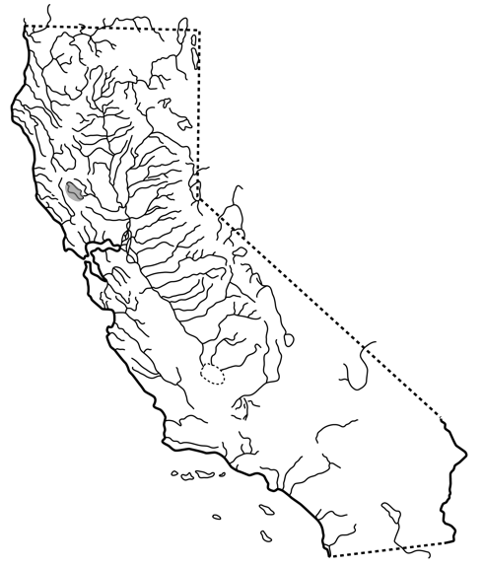

FIGURE X. Distribution of Clear Lake Prickly Sculpin, Cottus asper ssp. (Richardson), in Clear Lake, California.

